**Web_Lesson6: MongoDB and Application of D3.JS**

**Lesson Overview:**

This lesson involves introduction to MongoDB, D3.JS, importance of D3.JS programming of advanced visualization D3.JS

**Use case Description:**

Represent the Universities, their branches and departments in that university of a country in tree diagram

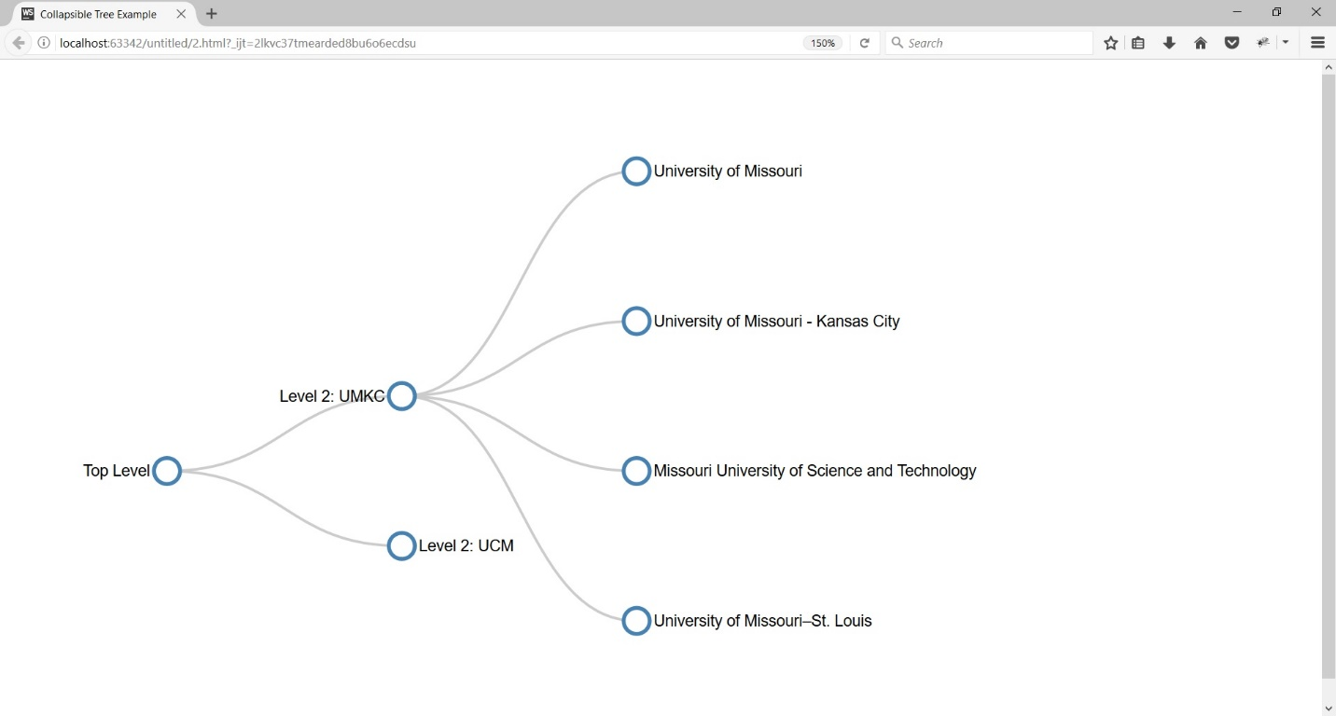

**Programming elements of D3:**

1. Introduction to MongoDB

2. Types of data formats used in D3 (SVG: Scalable Vector Graphics, CSV, JSON)

3. How to implement D3 inside HTML

4. How to call methods of D3

5. Methods available in D3( <https://github.com/d3/d3/blob/master/API.md>)

6. How to represent JSON data with D3.JS

**Source Code:**

<https://umkc.box.com/s/qh61c74x5r1ob1jcu87aksac6dihd228>

**In class exercise:**

Implement the Drag and Drop, Zoomable, Panning, Collapsible Tree with auto-sizing

**Reference:**

<http://bl.ocks.org/robschmuecker/7880033>

<http://bl.ocks.org/tizon9804/8540d89cc896927d35030cad2508324d>

Marks will be distributed between logic, implementation and UI

**Note:** Please don't forget to submit your feedback after the class. This helps a lot in increasing effectiveness of the course.

Use following link to submit your feedback: <https://goo.gl/forms/YKYg28wsHo7OnOa13>